Michigan Give Camp  July 17-19, 2009, Ann Arbor, MI | Evaluation & Feedback
First Name:_  Last Name:  E-Mail Address:  Phone Number:  Organization:  Address 1:  Address 2:  City:  State: Zip: State: Zip: | 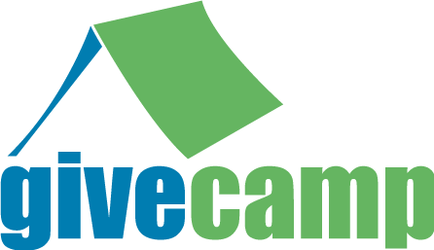
Nonprofit organization Developer/Designer
 | 1. OVERALL, how would you evaluate this event? (Choose the answer that best represents your opinion)
 |  | Poor  1 | 2 | 3 | 4 | 5 | 6 7 |  | 8 | Excellent  9
 | Event venue
 | Food at event
Charity selection
Effectiveness of your assigned team
 | Overall event rating
2. How did you hear about weekend’s event?
Partner MSDN Flash Microsoft employee User Group NEW Distribution List Twitter
Colleague Email Invite Website/Blog __________________________________ (please fill in)
3. Please answer these questions if you are with a non-profit organization.
I would come back next year. Yes No
I was happy with my development team. Yes No
I am satisfied with my finished website or software. Yes No
My new website is already live in production. Yes No
4. Please answer these questions if you participated in development/design of the software.
I would come back next year. Yes No
I used the shower facilities at WCC. Yes No
I found the stand-ups a valuable use of time. Yes No
I used the source control server provided by the Give Camp. Yes No
I viewed the live stream of Give Camp at http://www.ustream.tv/channel/aagivecamp. Yes No
I would like to be more involved in the selection of my nonprofit. Yes No
I twittered during the event. Yes No
I had the tools that I needed to complete the work. Yes No
I used the printer in the break room. Yes No
I would like to help with next year’s event. Yes No
Please estimate the number of hours that you spent working on your project(s): ____________
5. Please use space below for comments, both positive and negative, on this weekend’s event.

